Learned helplessness effects on cognitive ability and metacognitive accuracy
Reese Mengwasser, Eleanor Flanigan, Vicki Ferrarini
Department of Psychology, University of Wisconsin–Madison
Psych 505: Learning and Decision Making, Section 303
Dr. Ali Mohebi
May 3rd, 2026

Introduction (written by Reese Mengwasser, Edited by: Eleanor Flanigan and Vicki Ferrarini)
When an individual is exposed to repeated, unavoidable, negative outcomes, they develop a belief that they have no control over their environment and stop acting to prevent those negative outcomes. This state of inaction is known as learned helplessness. While first proposed by Martin Selignman, later work by B.F. Skinner demonstrates that learned helplessness is not induced by failure alone. Individuals must also recognize outcomes as uncontrollable, and perceive those outcomes as meaningful indicators of their own ability (Skinner, 1979, 1995). Anagram-based learned helplessness tasks, accompanied by self-evaluation tasks, show that individuals evaluate their own cognitive performance relative to task difficulty and beliefs about their own competence: when participants see task performance as a reflection of their general competence, failure produces decreased confidence, increased anxiety, and impaired future performance (Skinner, 1979).

Learned helplessness also decreases willingness to persist, as individuals exposed to uncontrollable tasks show reduced effort and engagement in subsequent performances (Gignac & Wong, 2018). From a motivational perspective, this reduction in persistence likely reflects a shift in perceived effort, where individuals no longer expect their actions to influence outcomes, leading to disengagement. Importantly, these effects may extend beyond behavior to metacognitive processes. Research on working memory has established a relationship between perceived competency and metacognitive ability, or one’s ability to monitor and evaluate their own cognitive processes. Effective performance on working-memory tasks, such as the Skinner anagram task, depends on integrating feedback across trials. Starke et al. (2017) found that stress and learned helplessness induced by a similar anagram task impairs decision making ability in the Iowa Gambling task, indicating that learned helplessness may disrupt adaptive learning mechanisms in addition to performance (Starcke et al., 2017). Because metacognitive monitoring relies on evaluating one's own performance and behavior adjustments, disruptions in perceived control and feedback integration may impair the accuracy of self- evaluations. Together, this suggests that perceptions of poor competence, uncontrollability, and physiological arousal may not only shape behavioral performance, but also the ability to accurately judge that performance.

This study aims to dissociate the effects of learned helplessness on performance from the effects of learned helplessness on judgments of performance. We use a version of Skinner’s anagram task to induce feelings of helplessness in participants, and examine how this manipulation affects both performance and self-evaluation on later tasks. By tracking both participants' performance and their metacognitive judgments, we aim to dissociate changes in perceived performance from changes in cognitive performance. This distinction is critical, as prior research suggests that subjective experience (feelings of cognitive fatigue) does not always align with objective performance, but may instead alter decision criteria or confidence levels (Wylie et al., 2021). Our perceptual judgement task will determine if learned helplessness affects sensitivity and cognitive performance, or confidence alone.

Hypothesis (written by: Reese Mengwasser, Vicki Ferrani)
We hypothesize that participants with learned helplessness will view their performance as worse on a task compared to control groups. We predict that induced helplessness will lead to lower confidence and more negative self-assessments. We predict that induced helplessness will lead to a more conservative decision criterion, but not necessarily decreased sensitivity.

Methods (written by: Eleanor Flanigan, Edited by: Reese Mengwasser)
English-literate participants were recruited from the experimenter pool of friends and family and asked to complete an online study. The experiment consisted of three tasks and six stages. The three tasks were a judgement task, a decipher task, and an evaluation task.

The judgement task asked participants to judge if a string of characters could form a proper word in English. Subjects were presented with a string of letters, asked if the string of letters can form a word, and prompted to make a choice between “Yes” or “No.” The decipher task asked participants, under a time limit, to unscramble a string of letters to form an English word and type that word into a response box. This task had two conditions, one for an experimental group, and one for a control. The experimental group was shown impossible anagrams (letter strings which cannot be untangled to form valid English words) while the control group only saw possible anagrams (letter strings which can be untangled to form valid English words). The evaluation task collected data on participants' metacognitive judgments in three domains, asking them to evaluate the difficulty of the previous task, how well they think they performed, and their overall confidence in their anagram processing ability. This was in the form of a short survey, identical for all participants and stages, with questions answered on a likert scale.

The structure of our study is as follows: to collect participants' baseline ability to process anagrams, all participants were first shown a version of the judgement task. Then, all participants were given the evaluation task to collect their baseline metacognitive judgements. Participants were then asked to complete the decipher task. We aimed to induce learned helplessness in the experimental group by showing mostly impossible anagrams (10), while the control group will only see possible anagrams. The evaluation task again followed for a comparative measure. Finally, all participants completed the second version of the judgement task (with a new set of strings), and then the final evaluation task. For all anagram tasks, we collected participants' response and reaction time to measure how their cognitive behavior changed across conditions. In conjunction with cognitive behavior, we used survey data to determine how learned helplessness affected participants' original judgment ability, perceived difficulty, and general confidence. Judgement task results were analyzed using signal detection theory. We analyzed evaluation task responses using a repeated measures analysis of variance.

Results and Discussion (written by: Eleanor Flanigan, Reese Mengwasser, Vicki Ferrarini)
Nineteen participants participated in our study (n = 7 control, n = 12 experimental). We first evaluated whether the learned helplessness manipulation produced the expected subjective effects. We then evaluated its consequences on response time, signal detection measures (sensitivity and criterion), and overall accuracy across the two judgement blocks.

To evaluate whether the manipulation produced the intended subjective effects, participants completed a 15-item Likert questionnaire at three points: baseline (Evaluation 1), immediately following the experimental manipulation (Evaluation 2), and after completing the judgement task (Evaluation 3). To isolate the immediate effect of the manipulation itself, we examined change from baseline to the post-manipulation evaluation. Participants in the experimental condition consistently evaluated their performance as worse compared to other participants, though their performance for the given condition was not significantly lower than other experimental condition participants. Thus, our manipulation was successful in lowering perceived ability in the experimental group.

We also compared reaction time between the pre-manipulation and post-manipulation judgement task. A 2 (condition) × 2 (block) mixed ANOVA on log-transformed mean reaction times revealed a significant main effect of block, F(1, 17) = 12.65, p = .002, with participants responding faster on Block 2 than Block 1. There was no main effect of condition, F(1, 17) = 0.37, p = .552, and critically, no condition × block interaction, F(1, 17) = 0.06, p = .804. Simple-effects analyses confirmed that both groups sped up significantly across blocks, and to a similar degree (control: dz = 0.91, p = .028; experimental: dz = 0.79, p = .015). The block effect therefore reflected a standard practice-related speedup that was unaffected by the manipulation.

Criterion and Sensitivity
We hypothesized that experimental participants would adopt a more conservative criterion (i.e., more positive c) on the second judgment task relative to the first, reflected in a significant condition × block interaction. The mixed ANOVA did not support this hypothesis. There was no main effect of condition, F(1, 17) = 2.69, p = .119; no main effect of block, F(1, 17) = 1.27, p = .276; and no significant interaction, F(1, 17) = 2.59, p = .126. Simple-effects analyses revealed that the descriptive pattern actually trended in the opposite direction from the prediction: control participants' criterion shifted toward greater conservatism across blocks (Δ = -0.51, p = .104, dz = -0.65), whereas experimental participants' criterion was essentially unchanged (Δ = +0.09, p = .695, dz = 0.12). The hypothesized increase in conservative responding among experimental participants was therefore not observed.

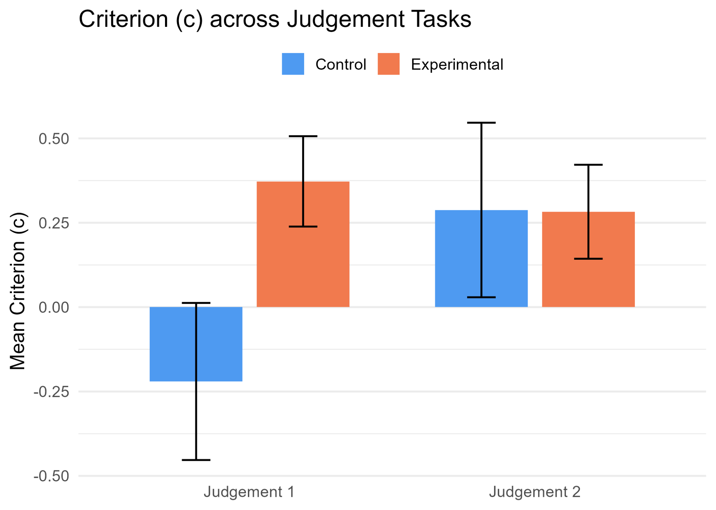
Figure 1: Figure 1 depicts the differences in criterion between the first and last judgment tasks. We see no statistically significant differences in the experimental group, however we do see a significant difference in criterion in the control group, with an increase in the mean criterion.

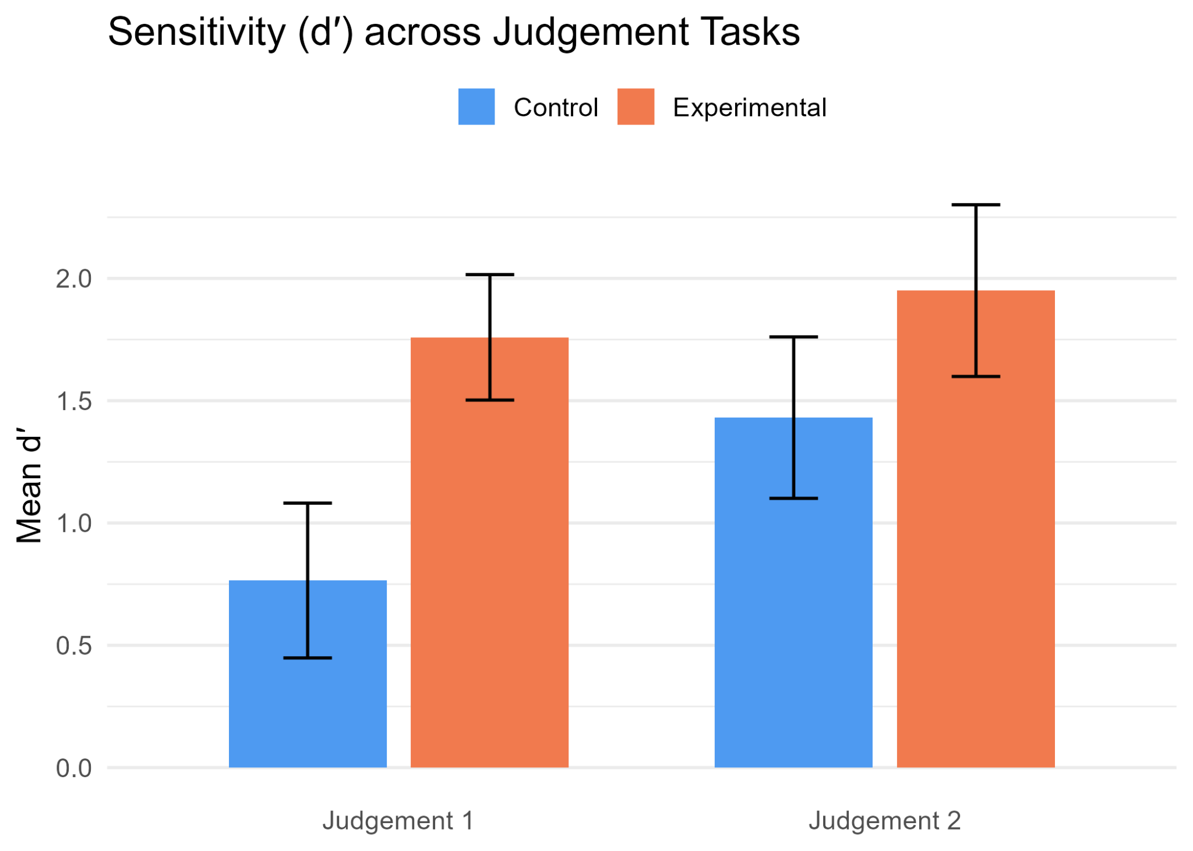
Figure 2: Figure 2 depicts the changes in sensitivity between the first and last judgments tasks. There was no significant difference in sensitivity in the experimental group. However, we did see a significant difference in sensitivity in the control group, with an increase in the mean sensitivity.

We predicted a limited effect on sensitivity for participants in the experimental condition. A mixed ANOVA on d’ revealed that control participants showed a higher sensitivity overall, F(1, 17) = 3.11, p = .096. The main effect of block was significant, F(1, 17) = 4.57, p = .047, indicating that sensitivity improved across blocks. The condition × block interaction did not reach significance, F(1, 17) = 1.40, p = .252. However, there is a notable asymmetry between conditions across blocks. Control participants improved substantially from block 1 to block 2, (Δ = 0.67, p = .052, dz = -0.79), whereas experimental participants showed a non-significant change change (Δ = 0.19, p = .443, dz = -0.23)

Changes in Metacognitive Evaluation
To test meta-cognitive evaluation after each task, participants completed a likert scale questionnaire asking them to evaluate their overall ability, task difficulty, and how their performance on the task related to their general intelligence and ability. For analysis, we compared both Evaluation 2 and Evaluation 3 to baseline responses in Evaluation 1 using an independent-samples t-test. Likert scale data was balanced so that higher scores reflected a more positive outlook, where lower scores reflected a negative outlook, regardless of the original question direction.

After the experimental manipulation, the decipher task, 8 of the 15 items showed significant condition differences, all with very large effect sizes (ds ranging from 1.13 to 2.07). Across these items, control participants' responses moved in a more positive direction over the session, while experimental participants' responses moved in a more negative direction (Figure 3). The significant items were those assessing state-level evaluations of task performance, ability, and experience (e.g., satisfaction with performance, perceived task ease, comparative ability on the just-completed task). This pattern shows that our decipher task altered participants' subjective judgments in the direction predicted.

After completing another version of the judgment task, we collected participants' responses to the same likert scale again (Evaluation 3). From Evaluation 1 to Evaluation 3, only 2 of the 15 items showed significant condition differences. The two questions showing significant changes from baseline response were “My performance on this task reflects how capable I am of solving difficult problems,” (t = 2.38, p = .040, d = 1.13) and “This anagram task is a reflection of my intelligence.” (t = 2.88, p = .018, d = 1.37). Both questions showed a positive change in the control condition and a negative change in the experimental condition, indicating that after the experimental manipulation, the changes in perception of connection between task performance and intelligence were likely to persist, even when given a task for which participants had previously had marked less of an association between intelligence and performance (Figure 5).

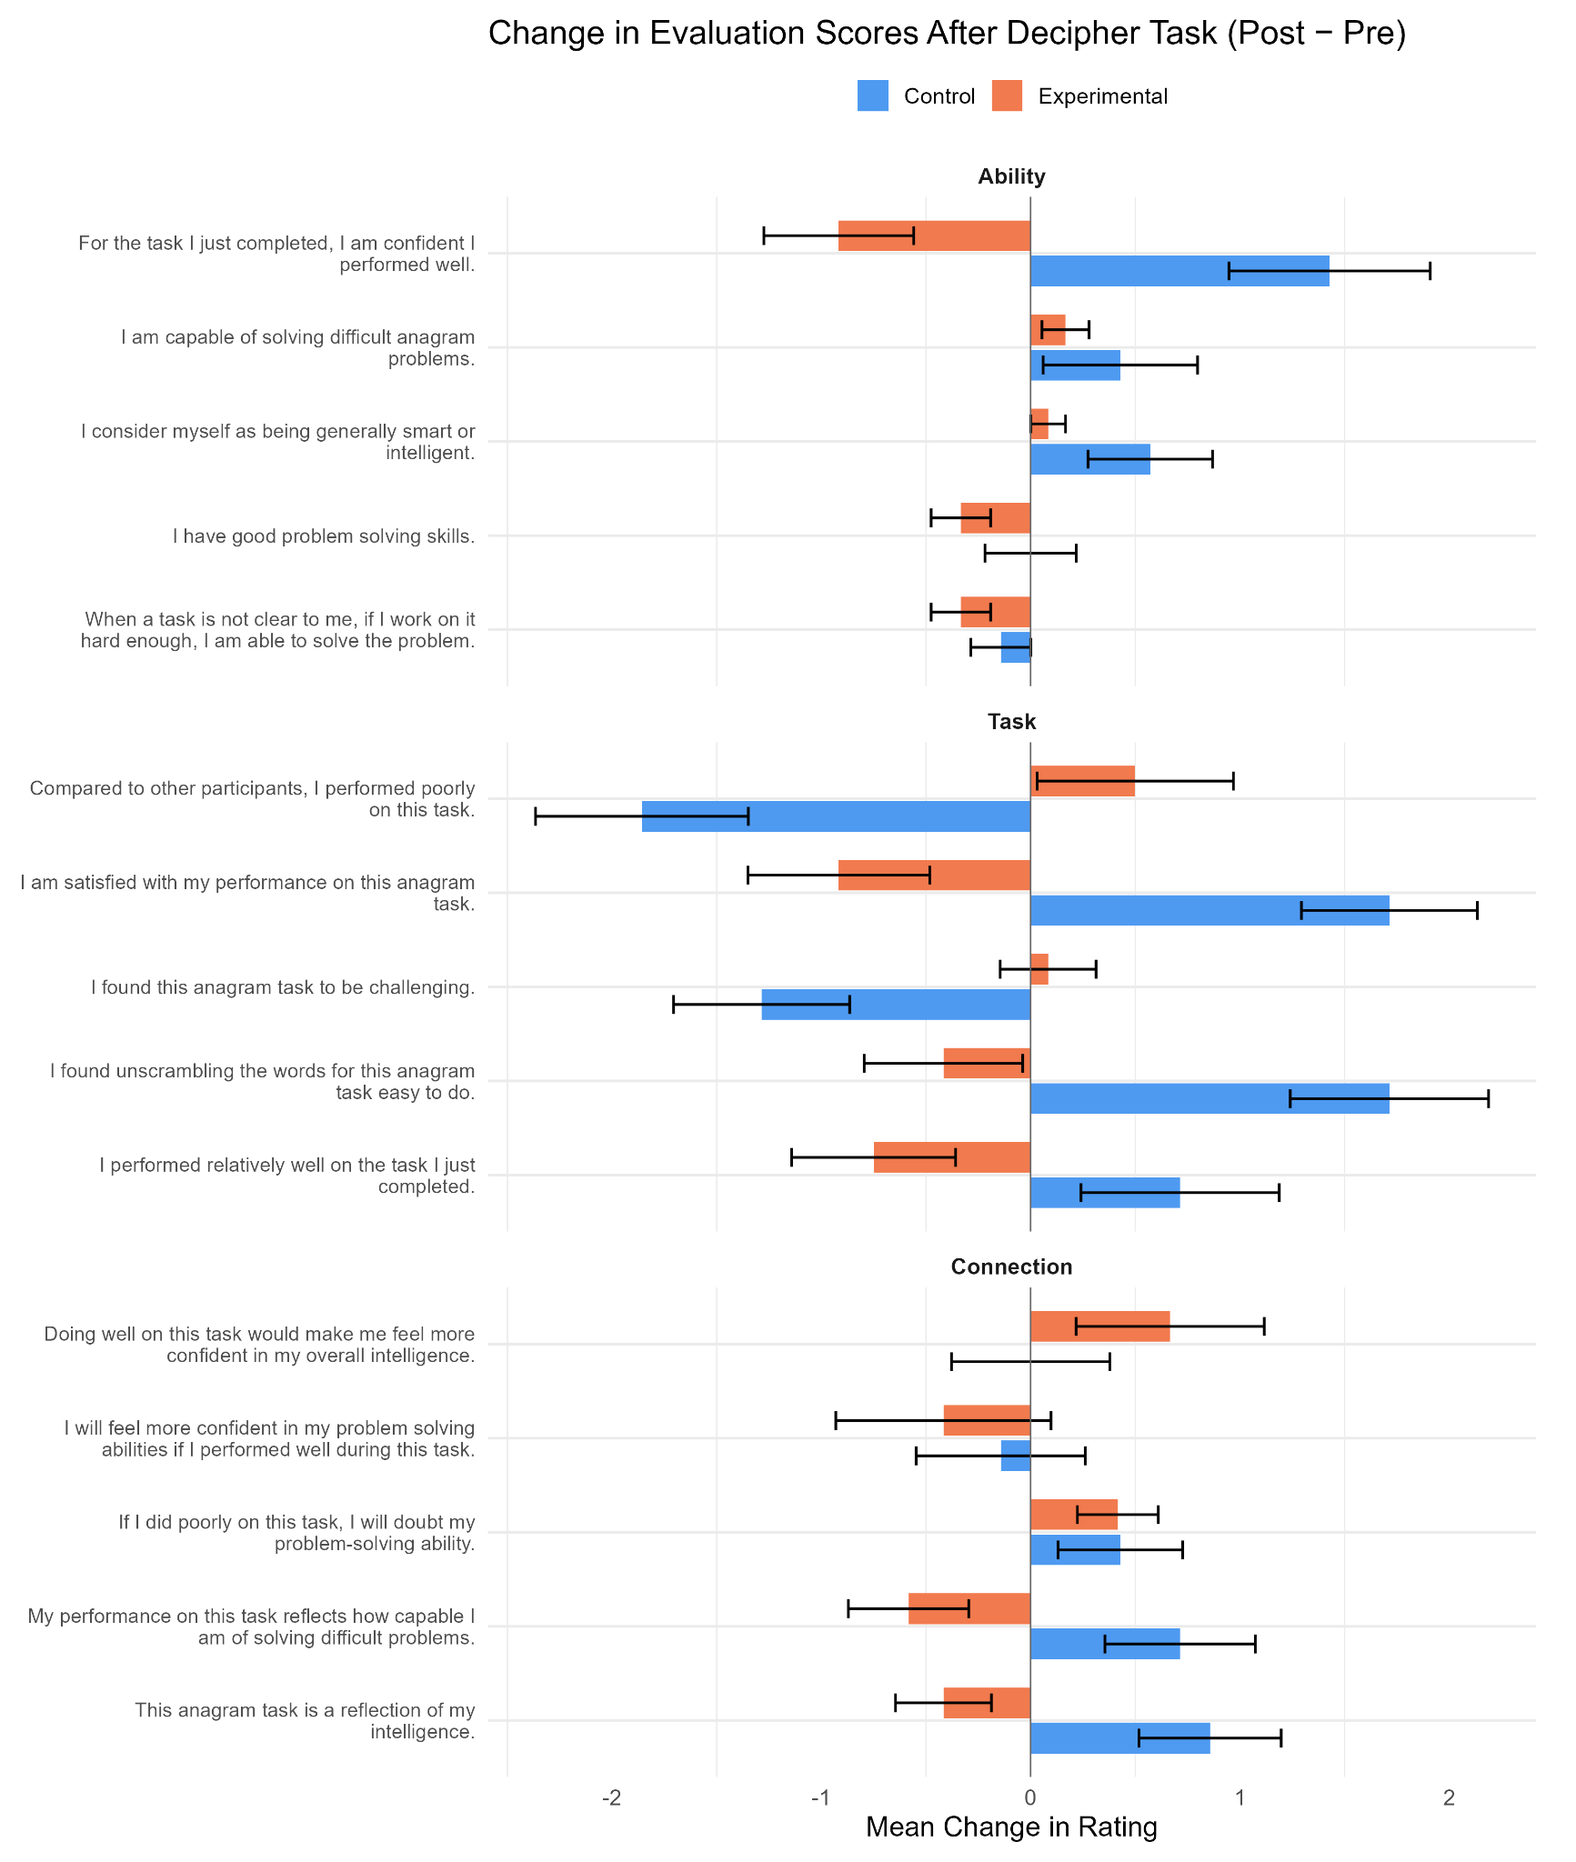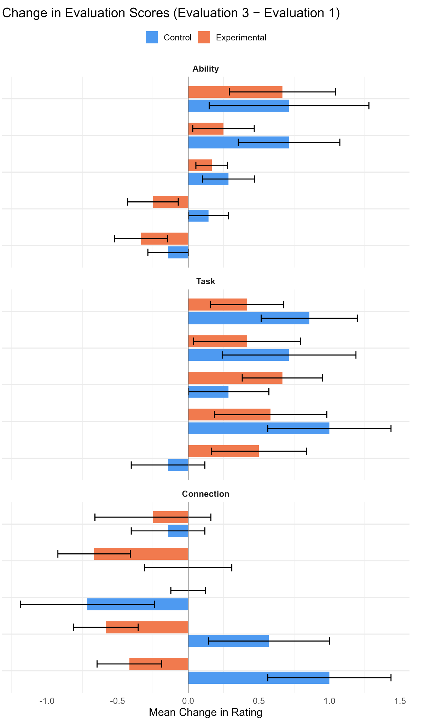

Figure 3: Figure 3 shows each of the mean change in rating in the questions asked in the evaluation tasks. The left side shows changes between Evaluation 1 and Evaluation 2, (baseline to post-experimental) while the right shows changes in Evaluation 1 and Evaluation 3 (baseline to after the second judgment task).

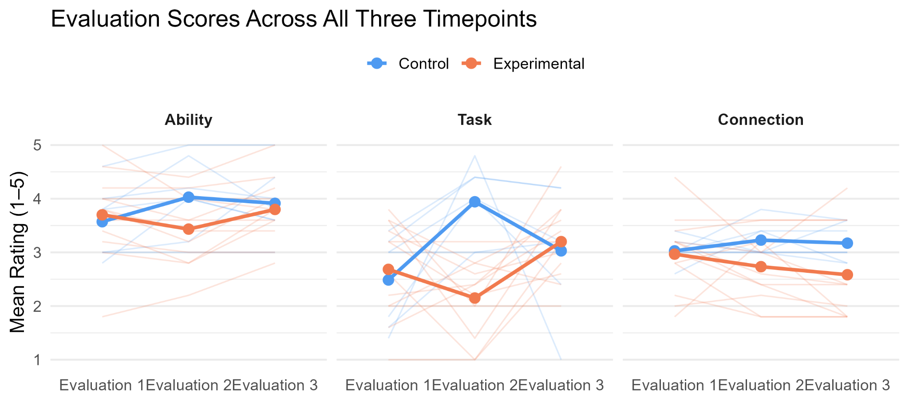
Figure 5: Figure 5 depicts the evaluation scores across all three evaluation tasks across the three types of questions asked: ability, task, and connection. Experimental participants rated their task specific ability and task performance more negatively for the experimental task, but ratings converged with the control group for the subsequent judgment task. However, changes in ratings of intellectual ability, as it relates to task performances, persisted after the experimental manipulation and after the second judgement task.

Overall, these findings provide partial support for our hypothesis. We predicted that the learned helplessness group would show lower confidence, more negative self-evaluations, and a more conservative decision criterion after the decipher task. The results did not show a clear decrease in sensitivity or accuracy for the experimental group, suggesting that the manipulation did not strongly impair basic judgement ability. However, the control group improved in sensitivity and accuracy. This suggests that the control group may have benefited from practice with solvable anagrams, whereas the experimental group may have been prevented from showing the same improvement after exposure to mostly impossible anagrams.

The evaluation results were more consistent with our hypothesis. Participants in the experimental group generally showed less positive change in confidence and self- evaluation after the decipher task. This suggests that learned helplessness may have affected how participants judged their own ability more than it affected their actual performance. In other words, the manipulation may have changed metacognitive judgements without producing a strong decline in sensitivity.

The sensitivity asymmetry between blocks across conditions indicates that control participants were able to improve on the judgement task, whereas the experimental participants did not. If our learned helplessness manipulation was effective, and our control group had a limited benefit from practice effects in the decipher task, learned helplessness may have limited experimental participants ability to discriminate between solvable and unsolvable anagrams, consistent with the idea that learned helplessness affects cognitive performance.

The results partially supported our hypothesis. We predicted that the learned helplessness group would show lower confidence, decreased performance, and a more conservative decision criterion after the decipher task. However, the experimental group did not show a significant decrease in sensitivity or accuracy, suggesting that the manipulation did not strongly impair their ability to distinguish possible from impossible anagrams. Instead, the clearest effect appeared in self-evaluation, whether the experimental group showed less positive changes in confidence and perceived ability. This suggests that the learned helplessness may affect metacognitive judgement more than actual cognitive performance. Skinner (1979) argued that learned helplessness depends on whether failure is interpreted as meaningful to one's own ability. In our study, impossible anagrams may have made participants feel less confident, even though their judgement performance did not clearly decline. The findings also connect to signal detection theory because sensitivity and criteria separate actual ability from response strategy (Lynn and Barrett, 2014). Since sensitivity did not significantly decrease, basic atas ability appeared most stable. However, the evaluation results suggest that participants' beliefs about their performance changes. This also fits research showing that unsolvable anagrams and cognitive fatigue can affect decision making, confidence, and response strategy without always causing a direct performance drop (Starcke et al., 2017, Wylie et al., 2021).

A limitation of this study was the small sample size, with 12 experimental participants and 7 control participants. The online format may have also weakened the learned helplessness manipulation because participants could not compare their performance to others. In addition, because our experimental tasks have a relatively few number of trials, our signal detection theory analysis may have been underpowered. Further work with more extensive trials may give a more accurate analysis of sensitivity and criterion. Future research should use a larger sample and include a manipulation check to confirm whether participants actually felt helpless. Overall, learned helplessness appeared to affect self- evaluation more than objective judgement performance. The experimental group did not significantly decline, but they also did not improve like the control group. This supports the idea that uncontrollable failure can change how people interpret their own ability before it clearly changes performance.

Future Directions and Limitations (written by Reese Mengwasser and Eleanor Flanigan)
Due to limited time to collect data, our sample size was small, which could lead to our results not having enough power. By increasing sample size in the future, we could possibly see different or greater effects of our manipulation. In addition, Skinner’s original anagram task was completed in a social setting, where participants in the experimental and control conditions completed the task simultaneously in a classroom setting. If participants could see how their peers performed, and had the impression that they were performing comparatively poorly on the same task, this may have induced stronger feelings of learned helplessness than completing the task alone. Since our participants completed their task online, in a non-social setting, they may not have had any feeling of learned helplessness because they didn’t have the effect of social comparison. We also did not have enough time to norm our task to counteract any positive bias that could’ve occurred throughout the experiment, and especially our likert scale. Given more time, we could’ve ensured that our experimental task induced learned helplessness, which could have affected our results as well.

References

Coldren, J. (2026, March 26). Conditions under which college students cease learning. Frontiers in Psychology. https://doi.org/10.3389/fpsyg.2023.1116853
Conte, N., Fairfield, B., Padulo, C., & Pelegrina, S. (2023). Metacognition in working memory: Confidence judgments during an n-back task. Consciousness and Cognition, 111, 103522. https://doi.org/10.1016/j.concog.2023.103522
Gignac, G. E., & Wong, K. K. (2018). A psychometric examination of the Anagram Persistence Task: More than two unsolvable anagrams may not be better. Assessment, 27(6), 1199–1211. https://doi.org/10.1177/1073191118789260
Lynn, S. K., & Barrett, L. F. (2014). “Utilizing” signal detection theory. Psychological Science, 25(9), 1663–1673. https://doi.org/10.1177/0956797614541991
Sedek, G., & Kofta, M. (1990). When cognitive exertion does not yield cognitive gain: Toward an informational explanation of learned helplessness. Journal of Personality and Social Psychology, 58(4), 729–743. https://doi.org/10.1037/0022-3514.58.4.729
Skinner, N. F. (1979). Learned helplessness: Performance as a function of task significance. Journal of Psychology, 102(1), 77–82. https://doi.org/10.1080/00223980.1979.9915097
Starcke, K., Agorku, J. D., & Brand, M. (2017). Exposure to unsolvable anagrams impairs performance on the Iowa Gambling Task. Frontiers in Behavioral Neuroscience, 11, Article 114. https://doi.org/10.3389/fnbeh.2017.00114
Tachtsidis, I., Leung, T. S., Tisdall, M. M., Devendra, P., Smith, M., Delpy, D. T., & Elwell, C. E. (2008). Investigation of frontal cortex, motor cortex and systemic haemodynamic changes during anagram solving. Advances in Experimental Medicine and Biology, 614, 21–28. https://doi.org/10.1007/978-0-387-74911-2_3
Wylie, G. R., Yao, B., Sandry, J., & DeLuca, J. (2021). Using signal detection theory to better understand cognitive fatigue. Frontiers in Psychology, 11, Article 579188. https://doi.org/10.3389/fpsyg.2020.579188
Yang, R., & Benjamin, A. S. (2026). Metacognitive control of workflow enhances stimulus discriminability and reduces signal uncertainty. Journal of Experimental Psychology: Learning, Memory, and Cognition, 52(3), 352–365. https://doi.org/10.1037/xlm0001499

Contributors
Programming: Eleanor Flanigan
Presentation: All members
Introduction: All members
Methods: All members
Results: Eleanor Flanigan
Discussion: All members
References: All members

